

Thanks for purchasing my asset , if you have any problem feel free to contact me at [madfireongames@gmail.com](mailto:madfireongames@gmail.com).

Scripts

DotController – It controls the speed of dot.

InputManager – It keep track of input touches made by player.

SpawnController –It controls the number of dots to be spawn , scoring system and how much the dot speed should be.

Tile – It is the script attached to the dots which are at bottom , this script controls the movement and all the detections done by tile.

GameManager – It take care of saving and loading data on the device and other important functions.

InGameGuiManager – It controls the game menu.

MainMenuManager – It controls the main menu.

UnityAds- It controls the ads.

ObjectPooling – It supply the dots to spawner.

GooglePlayInGame – This take care of google services.

ShareScript – It controls the screen shot sharing function.(Present only android support this)

Managers

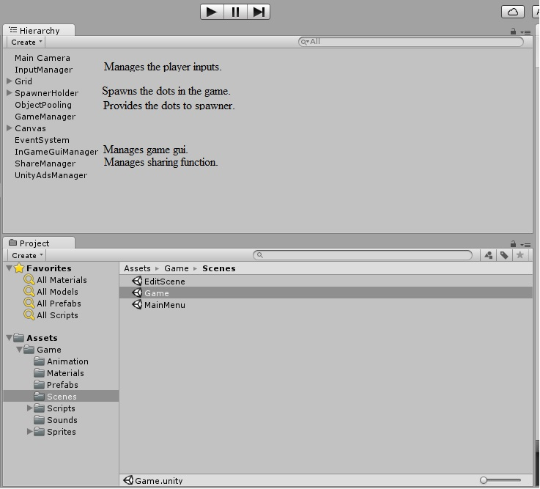

Grid

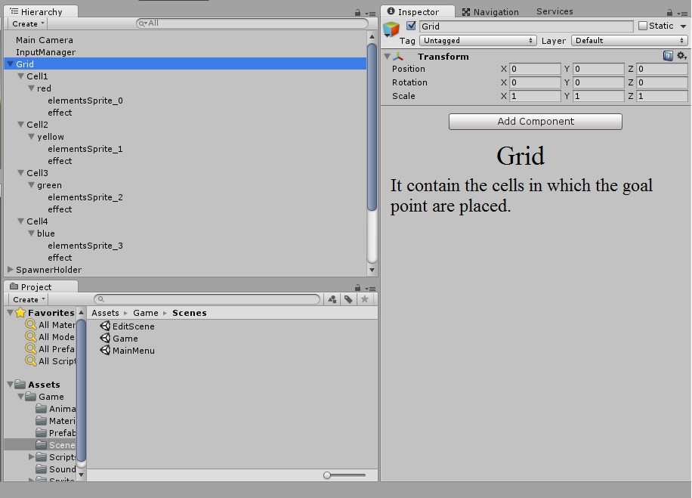

It holder the tiles which player moves.

InGameGuiManager

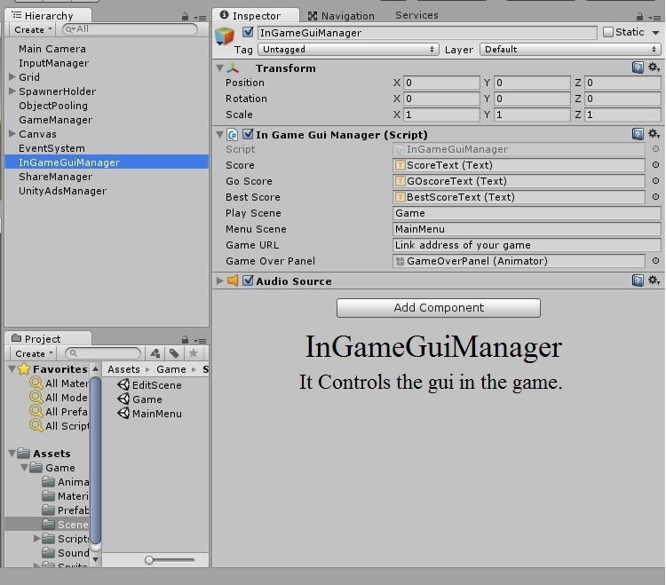

It manages game gui.

SpawnHolder

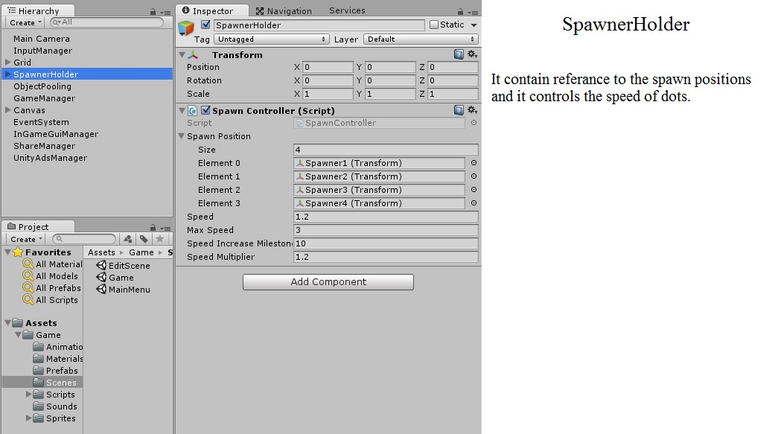

It contains the positions where we spawn dots , speed for dots , milestones to increase the speed , etc.

Important Note: To implement unity Ads and google play services you must import there assets and follow the basic procedure.

Thanks for purchasing the asset , you guys encourage me to make more games. If you have to make any changes to game tell me and I will try to make it happen.